Cell Size and Diffusion
Introduction
You have learned that virtually all living cells are dependent on the process of diffusion in order to obtain the essential nutrients they need in order to survive. As cells take in these nutrients, they break them down and use the resulting energy and molecular building blocks to make more cellular components. This causes a cell to grow by increasing in size. However, cells never get too big, even if the organism is rather large. Cells are always small. In other words, the cells of an ant and a horse, are, on average, the same size; a horse just has a lot more of them.
These observations raise an interesting question: Why are cells so small?
Here are two potential answers to this question:
● Claim 1: Cells that have a larger surface area to volume ratio are more efficient at diffusing essential nutrients.
● Claim 2: The rate of diffusion is related to cell size. Nutrients diffuse through small cells faster than they do in large cells
Methods
You can test the validity of these different explanations by constructing a model cell using agar. Agar is a gel-like substance that you can cut into whatever shape or size you want. Chemicals diffuse through agar. A chemical indicator has been added to this agar. When the indicator comes into contact with an acid, it changes color. This allows you to see how far an acid diffuses into your model cell over time.
You will have the following materials available to use during your investigation:
- Indicator-agar cubes
- Weak acid
- Beakers
- Stopwatch
- Ruler
- A plastic knife.
Procedure
Safety notes: Wear goggles and gloves when dealing with the weak acid solution and indicator-agar cubes.
With your group, determine which explanation provides the best answer to the research question. You can use as many of the supplies available to you to test your ideas. Make sure that you generate the evidence you will need to support your explanation as you work. You can record your method and any observations you make in your lab notebooks.
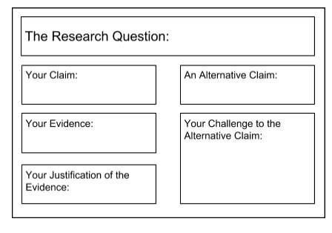
Argumentation
Once your group has decided which explanation is the most valid or acceptable answer to the research question, prepare a large page that you can use to share and justify your ideas. Your large page should include all of the information shown to the right and be in your lab notebook. To share your work with others, we will be using a round-robin format. This means that one member of the group will stay at your area to share your group’s ideas, while the other group members go to the other groups one at a time in order to listen to, and critique the arguments developed by your classmates. Remember as you critique the work of others, you need to decide if their conclusions are valid or acceptable based on the quality of their claim and how well they have been able to support their ideas. In other words, you need to determine if their argument is convincing or not.
One way to determine if their argument is convincing is to ask them some of the following questions:
- How did you gather your data?
- Why did you decide to do it that way?
- How do you know your data is high quality (free from errors)?
- How did you analyze or interpret your data?
- Why did you decide to do it that way? Why does your evidence support your claim?
- Why did you decide to use that evidence?
- Why is your evidence important?
- How does your justification of your evidence fit with accepted scientific theories.
Final Product
Once the session is complete, your group will write a one-page argument via google docs to support the explanation that you think is the most valid or acceptable. Your argument must also include a challenge to one of the alternative explanations As you write your argument, remember to do the following:
- State the explanation you are trying to support
- Include genuine evidence (data, analysis, and interpretation)
- Explain why the evidence is important and relevant
- State the explanation you are trying to refute
- Explain why the alternative explanation is invalid or unacceptable
- Organize your argument in a way that aides readability.
- Use a broad range of words including relevant vocabulary.
- Correct grammar, punctuation, and spelling errors.
This document, along with an image of your “poster” will be shared with me and then posted to the course blog. Please give me editing access to your google doc/poster

